**Step 1 : Deploy a Ubuntu 16.04 server**  **and** **ssh to the Ubuntu server**

##### **Step 1.A : Update your repo**

# apt-get update

**Step 2 :Install NTP packages**

# apt-get install ntp git maven default-jdk -y

**Step 6 :** **Go to Jenkins dashboard > Manage Jenkins > Manage nodes**

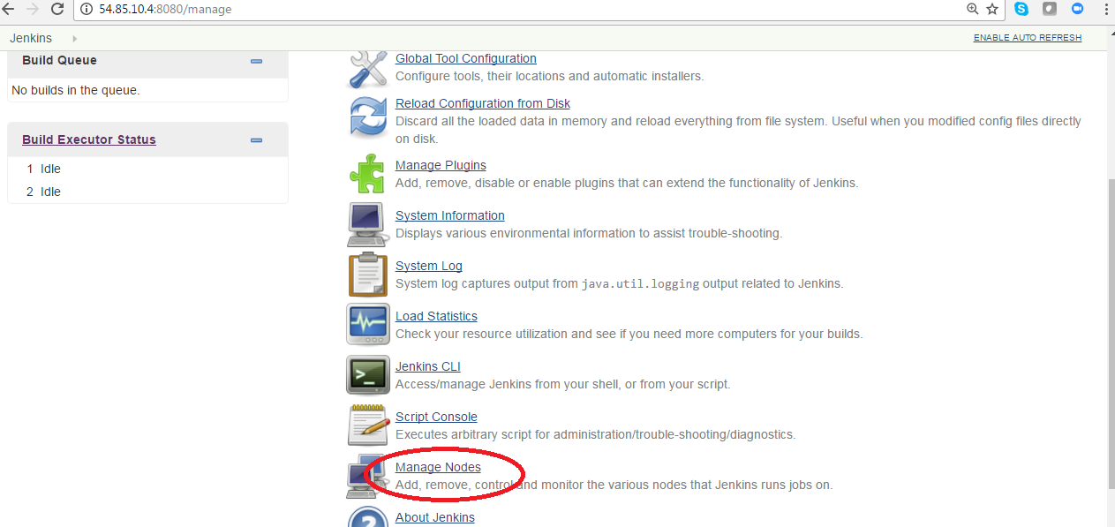

**Step 7:**  **click on new node**

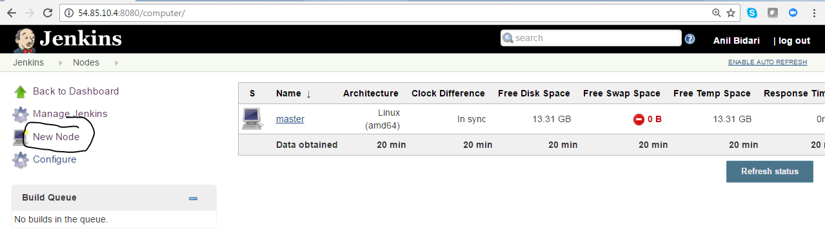

**Step 8 :**  **Provide name to node and click ok**

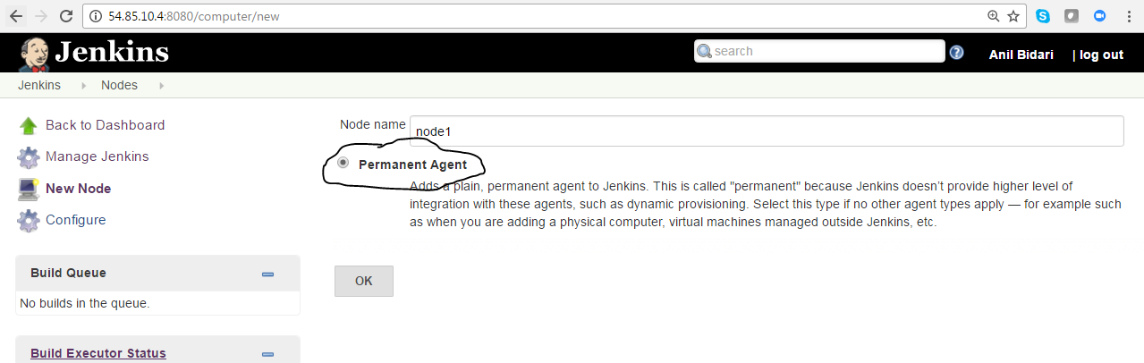

**Step 9 :**  **Provide your node details use launch slave agents via ssh and click add credentials**

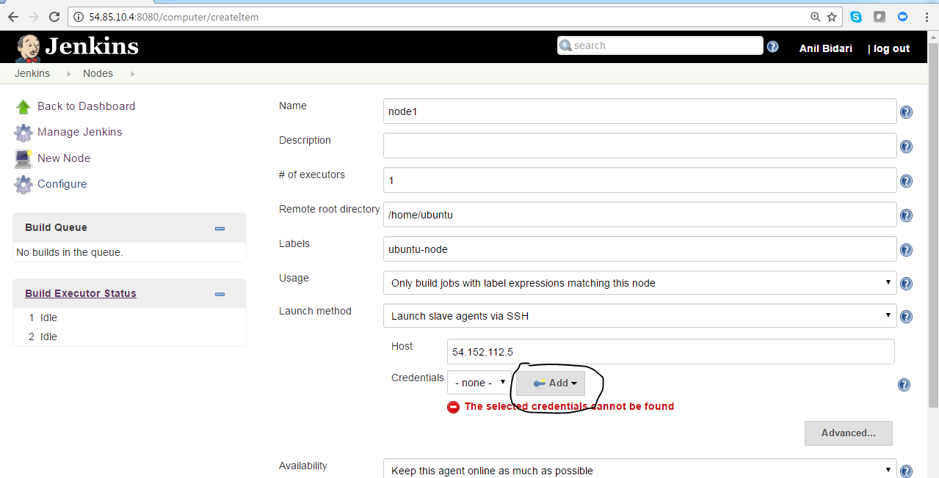

**Step 10 :**  **Add credentials ,node user name and ssh key of the node**

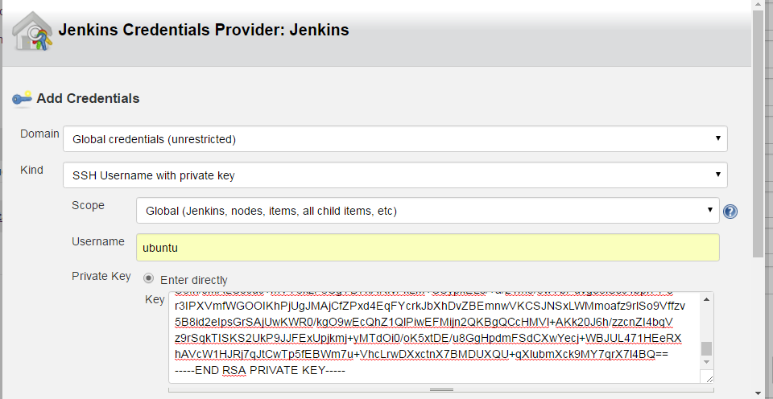

**Step 11 :**  **Select Ubuntu under and credentials and click save**

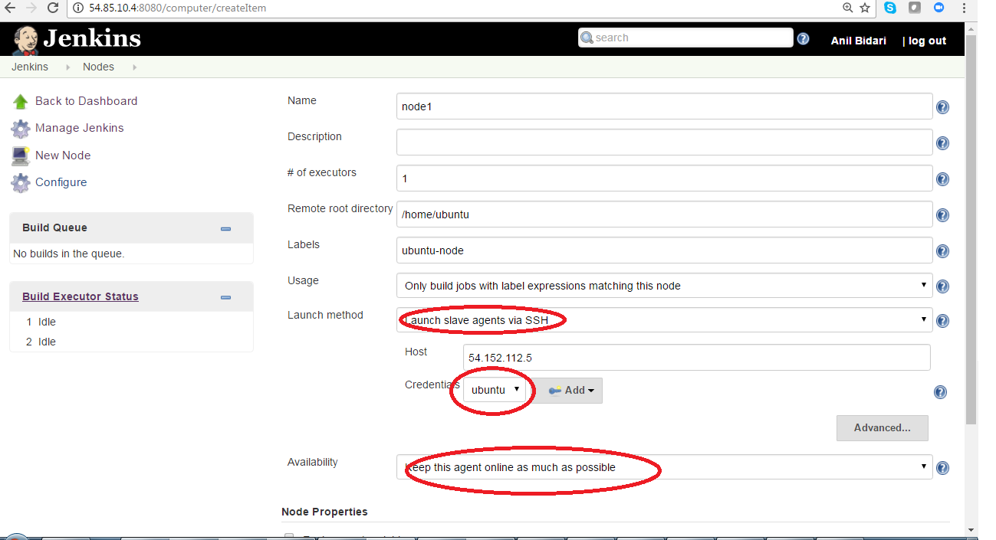

**Step 12:**  **Validate if node is online**

